**DATA ENABLED SMART WATER DISTRIBUTION SYSTEM**



**BTECH/II YEAR CSE/III SEMESTER**

**19CSE202/DATABASE MANAGEMENT SYSTEMS**

**GROUP -7**

|  |  |
| --- | --- |
| ROLL NO | NAME |
| CB.EN.U4CSE21106 | **ARUNKUMAR J** |
| CB.EN.U4CSE21107 | **ARVIND P** |
| CB.EN.U4CSE21114 | **KHARINANDAN D N** |
| CB.EN.U4CSE21126 | **SELVAKUMARAN K** |

**CASE STUDY REVIEW 3**

**ABSTRACT:**

* Provide adequate quantity of water as per CPHEEO standard to citizens
* Reduction in Non-Revenue Water (NRW)
* Reduce breakdowns and maintenance time
* Water and energy audit
* Provide tool to executives for improving their efficiency
* Effective and efficient management of water supply
* Increase transparency for citizens

**ENTITIES:**

1. Water quality
2. CEO
3. General manager
4. Sources
5. Water treatment
6. Commercial consumption
7. Residential consumption

**USER INTERFACE :**

1. 5 Web pages using HTML & CSS with JavaScript Validation
2. ER – Diagram, Schema – Diagram, Dependency Diagram

**WHAT HAPPENS WHEN ALL THE ATTRIBUTES ARE STORED IN A SINGLE TABLE?**

* When all the data are stored in a single database it will create be task to handle the data anomalies even when it is in 1NF

Our table has all the attributes which are atomic in nature and we should be able to identify brief out why it is in 1nf

* Data anomalies in our table are:
* **TABLE IN 1ST NORMAL FORM:**
* **TABLE IN 2ND NORMAL FORM:**
* **TABLE IN 3RD NORMAL FORM:**
  + Updation anomaly
  + Insertion anomaly
  + Deletion anomaly

**PROBLEMS FACED IN THE 1NF :**

* If you notice the above table, we can identify that there are 34 columns in 1 single table
* This brings us different anomalies such as insertion, updation and deletion.
  + Insertion anomaly – this occurs when you want to store the data of one row for some columns then you must enter values for all the columns else you can enter the values ( st_no is PK so to insert value for any columns you must insert all the values related to pk)
  + Updation anomaly – this occurs when we want to update value of one column then the changes should be reflected to other attributes as well but that shouldn’t be the same
  + Deletion anomaly – this occurs when we want to delete one particular column then we are forced to delete the values of the entire row

**FUNCTIONAL DEPENDENCIES FOR 1NF:**

St_no, Site -> WQ_Date

CEO -> C_ID

CEO -> C_Name

CEO -> C_Password

CEO -> C_Ph_no

St_no, Site -> WQ_Location

St_no, Site -> Samp_Class

St_no, Site -> Free_cl

Per_no -> St_no

Per_no -> Plant_type

Per_no -> Fac_Name

Per_no -> Hyd_flow

Per_no -> Street

G_ID -> G_Name

G_ID -> G_Password

G_ID -> G_Ph_no

G_ID -> G_Region

St_no -> Location

St_no -> State

St_no, C_Location -> Date

St_no, C_Location -> Cust_class

St_no, C_Location -> C_Gallons

St_no, R_Location -> Date

St_no, R_Location -> City_con

St_no, R_Location -> Per_con

St_no -> Temp

St_no -> Oxygen

St_no -> pH

St_no -> Conductivity

St_no -> Coliform

St_no -> Gallon

**DECOMPOSING THIS TABLE TO 2NF :**

**ATTRIBUTES:**

1. Water Quality: St_no, Site, WQ_Date, WQ_Location, Samp_Class, Free_cl
2. CEO : G_ID, G_Name, C_Password, G_Ph_no, G_Region,C_id,C_name,C_Phn;
3. Sources: St_no, Location, State, Temp, Oxygen, pH, Conductivity, Coliform, Gallon
4. Water Treatment: Per_no, St_no, Plant_type, Fac_Name, Hyd_flow, Street
5. Commercial Consumption: St_no, C_Location, Date, Cust_class, C_Gallons
6. Residential Consumption: St_no, R_location, Date, City_Con, Per_Con

**IS THERE ANY TRANSITIVITY DEPENDENCY?**

Yes, there is a transitivity dependency because the CEO determines the general manager and its sub-constituents where the general manager also determines the sub constituents which makes it a transitivity dependency.

**DECOMPOSING THIS TABLE TO 3NF :**

**ATTRIBUTES:**

1. Water Quality: St_no, Site, WQ_Date, WQ_Location, Samp_Class, Free_cl
2. CEO: C_ID, C_Name, C_Password, C_Ph_no
3. General Manager: G_ID, G_Name, G_Password, G_Ph_no, G_Region
4. Sources: St_no, Location, State, Temp, Oxygen, pH, Conductivity, Coliform, Gallon
5. Water Treatment: Per_no, St_no, Plant_type, Fac_Name, Hyd_flow, Street
6. Commercial Consumption: St_no, C_Location, Date, Cust_class, C_Gallons
7. Residential Consumption: St_no, R_location, Date, City_Con, Per_Con

**IS THE TABLE IN 3NF?**

1. We started off with our dataset where we decomposed the 1NF table to 2nd and verified it to be as 3nf
2. Our table is in 3NF because there is no transitivity dependency in the table

**Yes, the tables are in 3NF form.**

**IS THE TABLE IN BCNF:**

Yes, the tables are in BCNF because the super keys directly determine the all the other attributes in the table

**Yes, the tables are in BCNF form.**

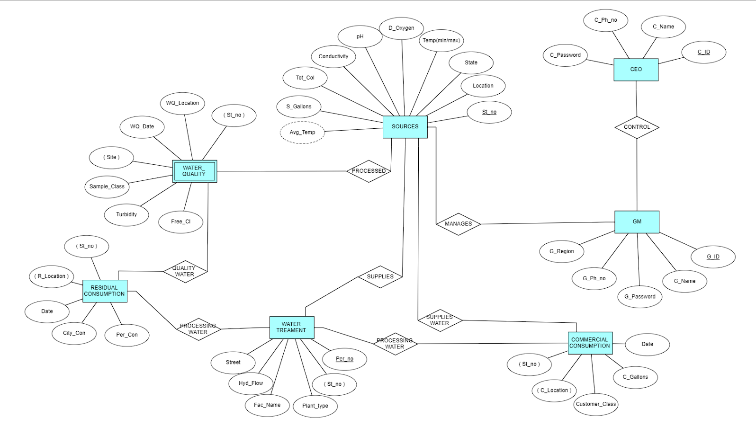**ER DIAGRAM FOR THE BCNF TABLE:**

**DEPENDENCY DIAGRAM FOR BCNF:**

**CEO TABLE:**

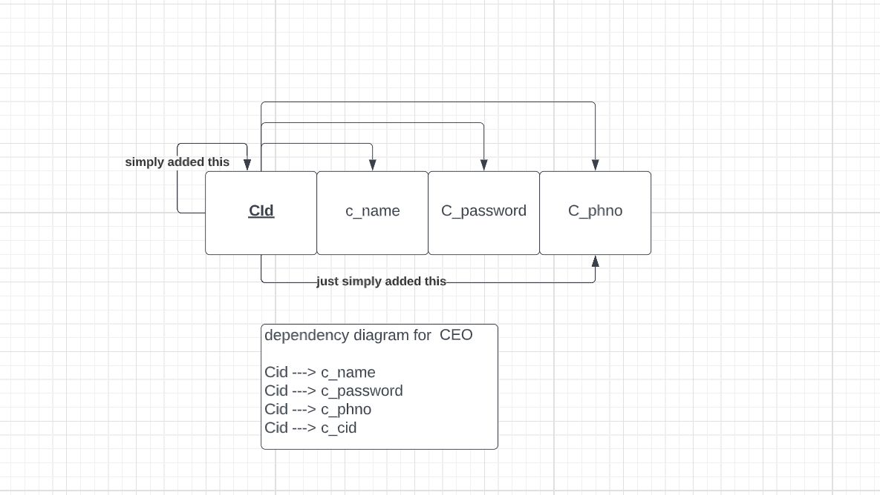

**SOURCES TABLE:**

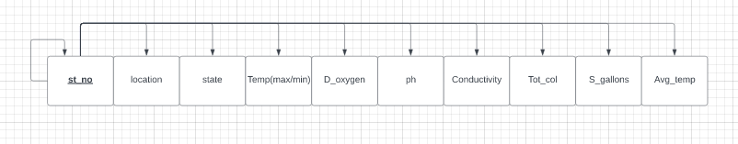

**WATER TREATMENT TABLE:**

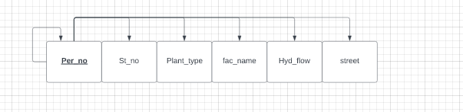

**WATER TREATMENT TABLE:**

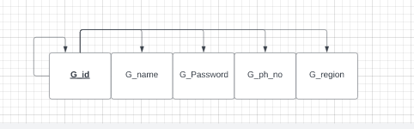

**WATER TREATMENT TABLE:**

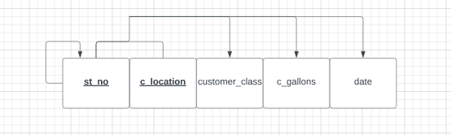

**WATER TREATMENT TABLE:**

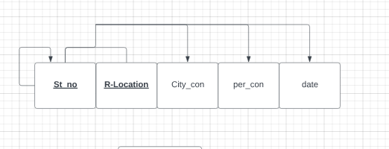

**WATER TREATMENT TABLE:**

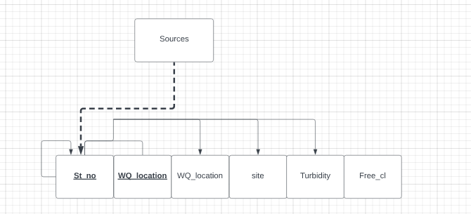

**CLOSURE OF FD:**

The closure of FD will continue to be the same as that of the primary key in the decomposed table OF BCNF

St_no, Site -> WQ_Date

CEO -> C_ID

CEO -> C_Name

CEO -> C_Password

CEO -> C_Ph_no

St_no, Site -> WQ_Location

St_no, Site -> Samp_Class

St_no, Site -> Free_cl

Per_no -> St_no

Per_no -> Plant_type

Per_no -> Fac_Name

Per_no -> Hyd_flow

Per_no -> Street

G_ID -> G_Name

G_ID -> G_Password

G_ID -> G_Ph_no

G_ID -> G_Region

St_no -> Location

St_no, C_Location -> Date

St_no, C_Location -> Cust_class

St_no, C_Location -> C_Gallons

St_no, R_Location -> Date

St_no, R_Location -> City_con

St_no, R_Location -> Per_con

St_no -> State

St_no -> Temp

St_no -> Oxygen

St_no -> pH

St_no -> Conductivity

St_no -> Coliform

St_no -> Gallon

**CANONICAL COVER:**

The canonical cover of FD will also continue to be the same as that of the primary key in the decomposed table because there is no such extraneous attribute in the table that can be minimized

**SCHEMA DIAGRAM:**

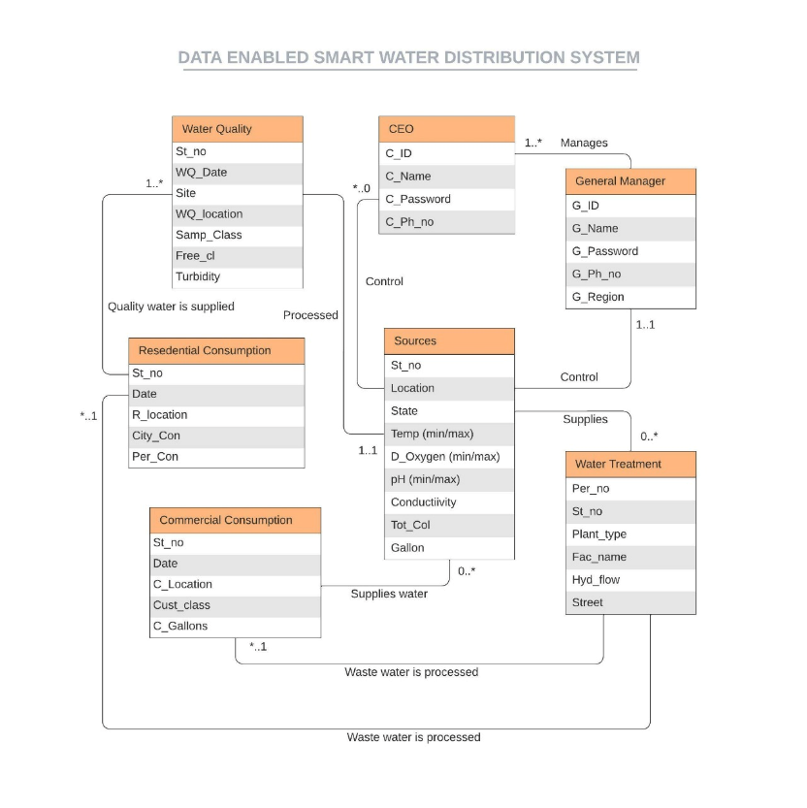

**IS THE DECO****MPOSITION LOSSLESS?**

Since we have decomposed the original table into 7 main tables we must ensure that the dependencies between the attributes remains the same, So to ensure that it is lossless we use chase method to confirm that it is lossless

**CLICK HERE TO SEE THE** [**CHASE METHOD**](DBMS.docx)

**UI DESIGN PART:**

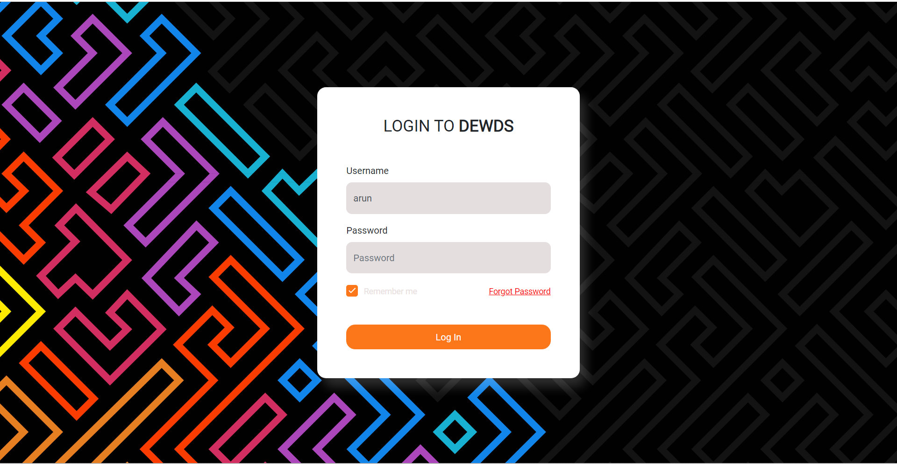

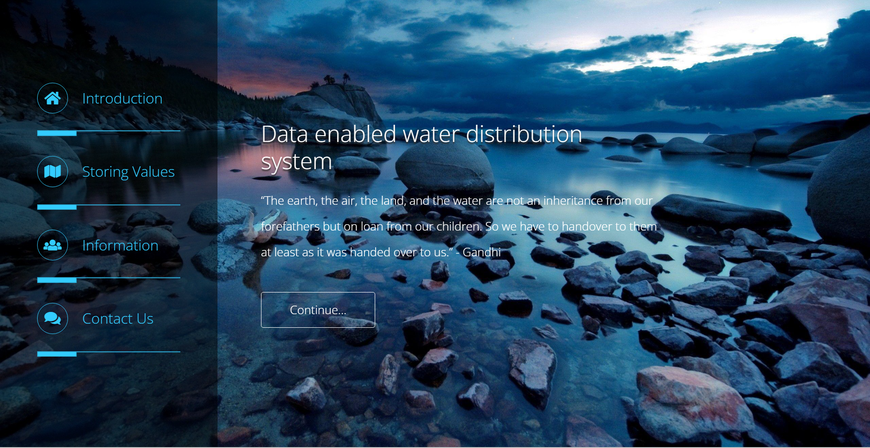

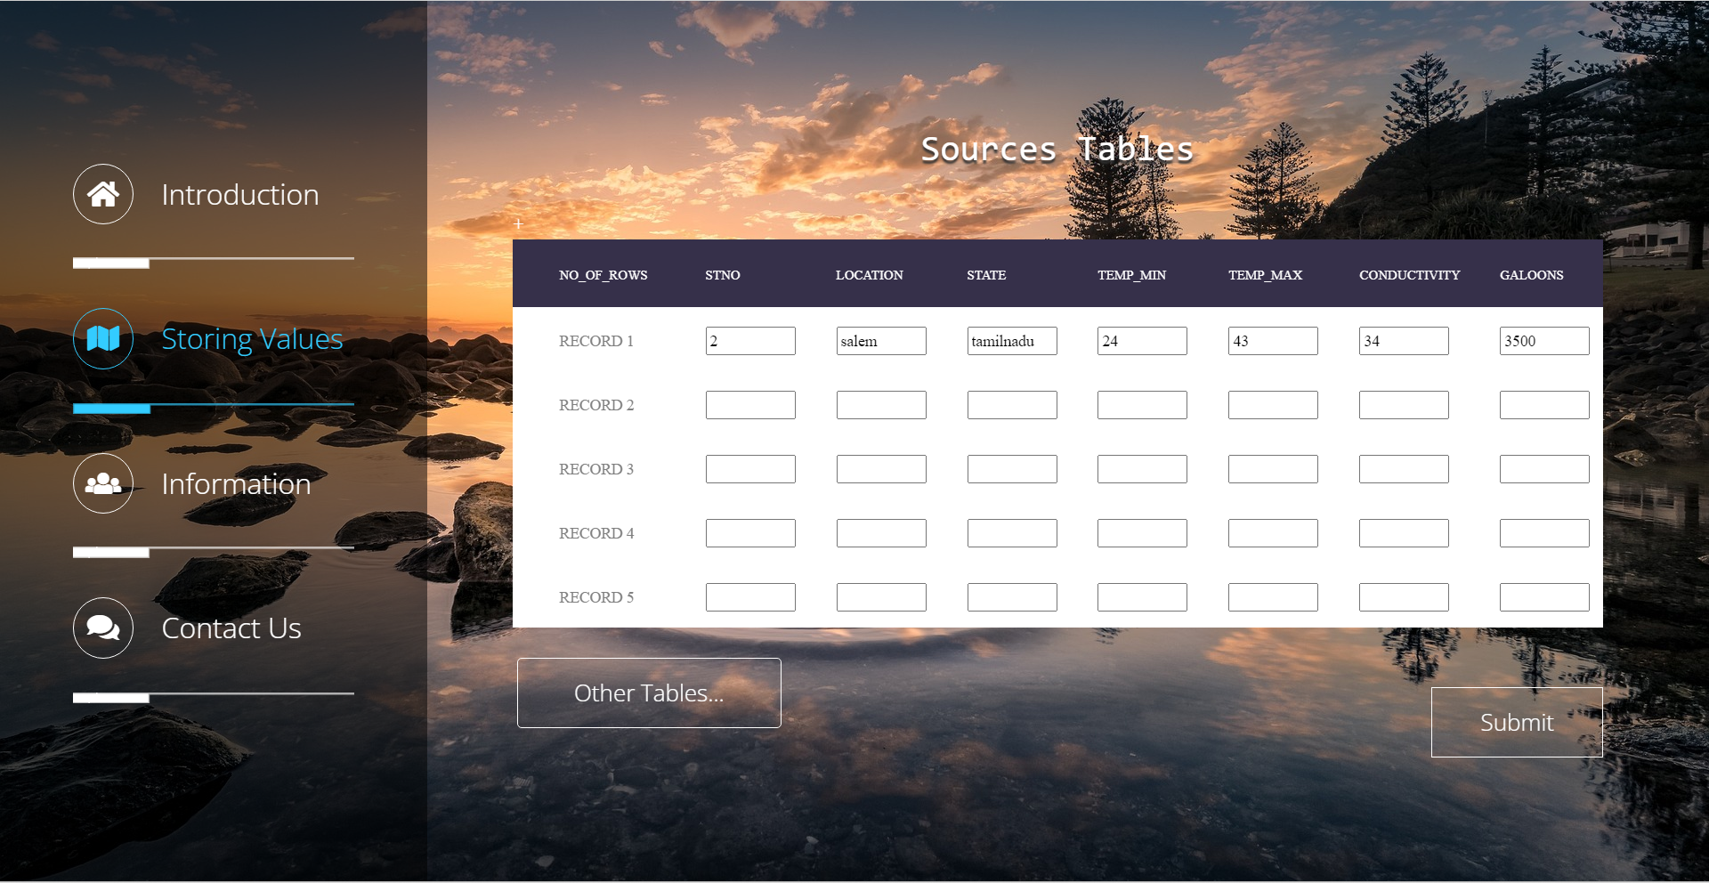

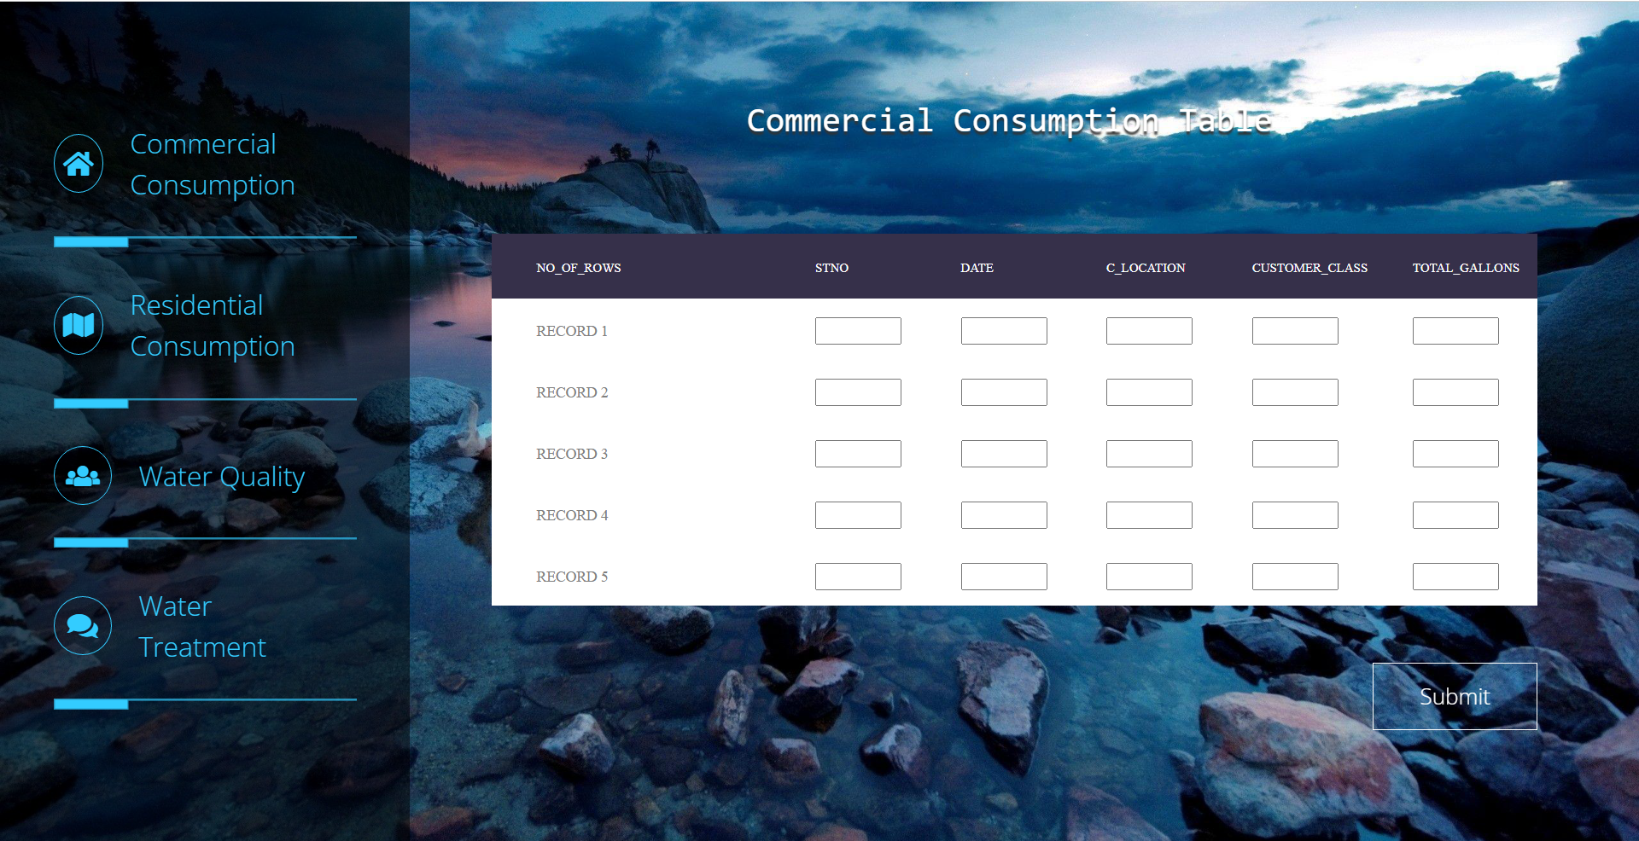

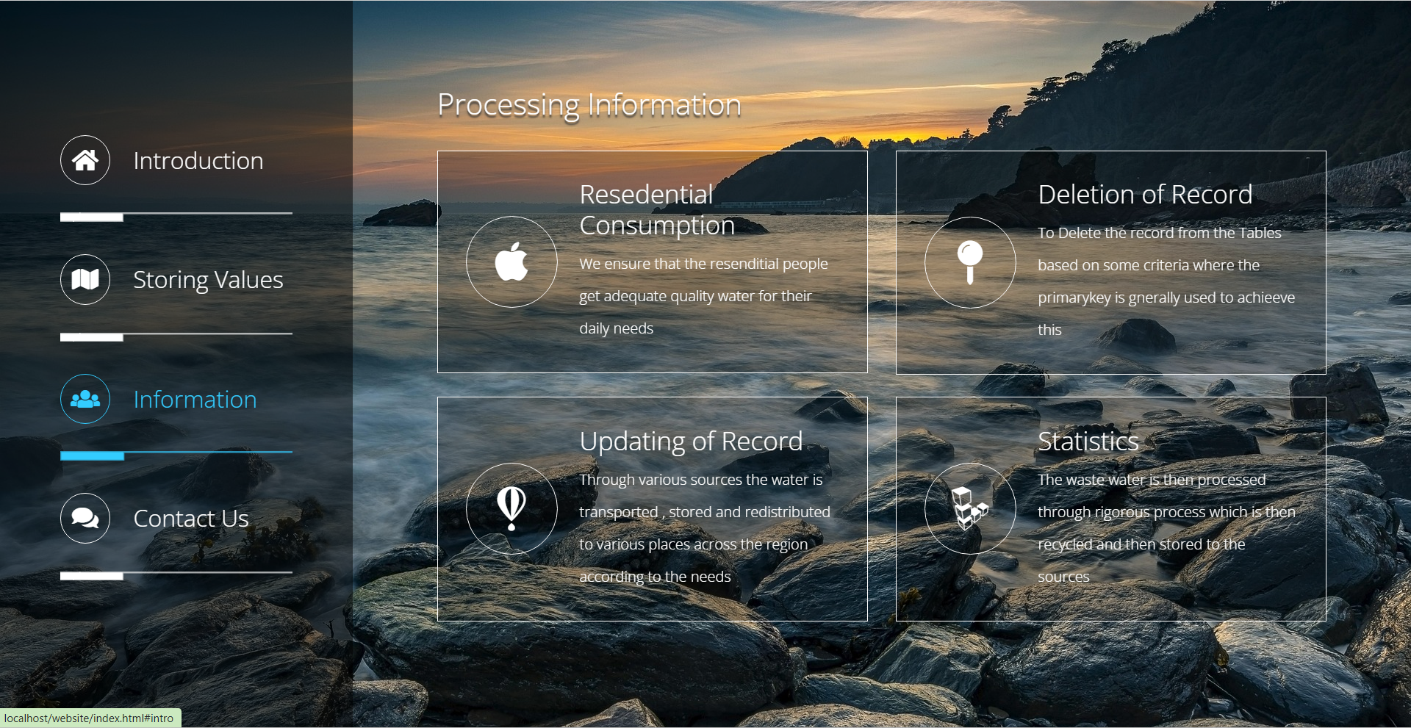

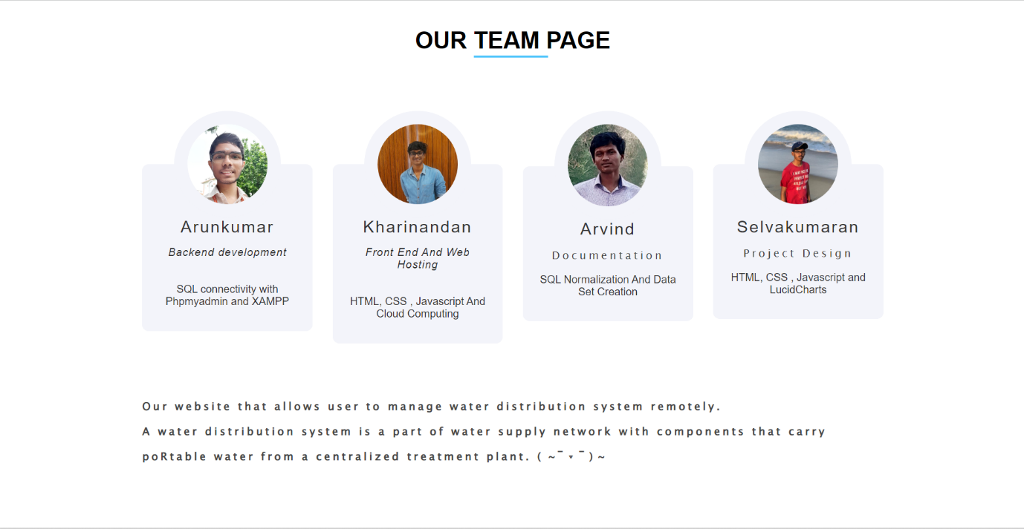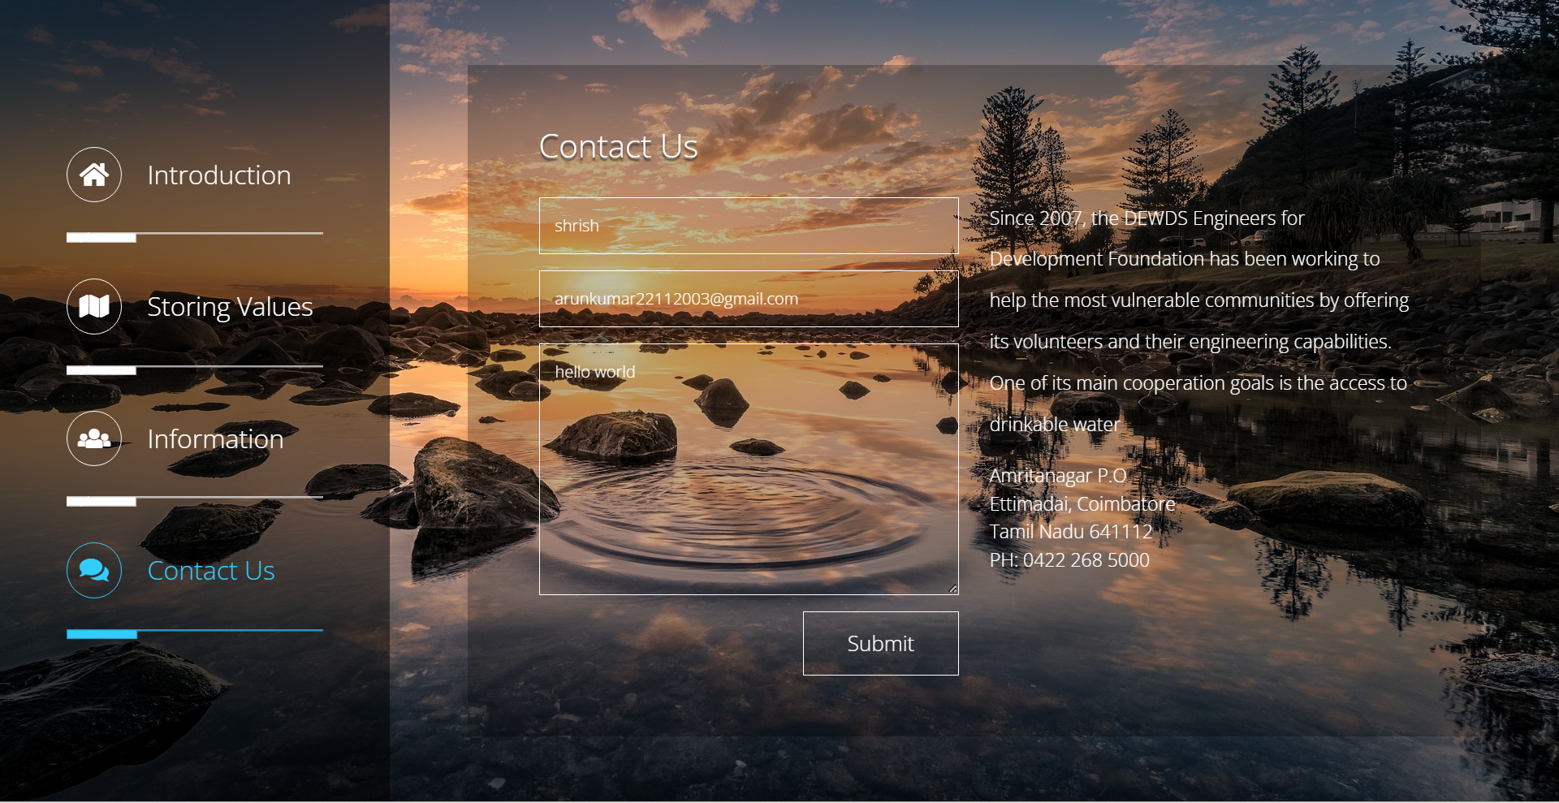

**ANALYSIS:**

The analysis was made using Jupyter notebook where the contents and graph which we will be using are dynamic in nature where it will change its value and plots according to the change in data values in the data set in the database

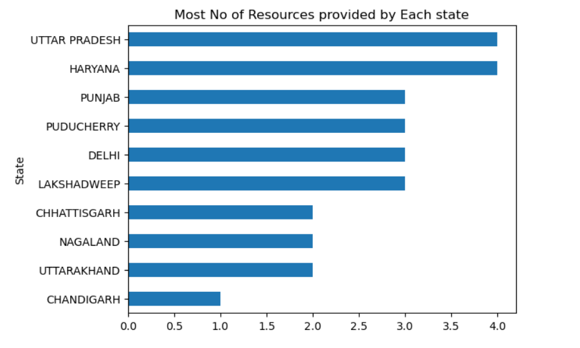

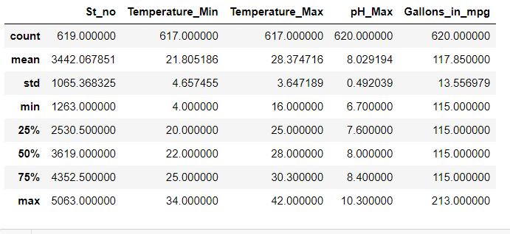

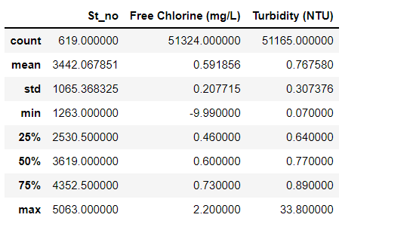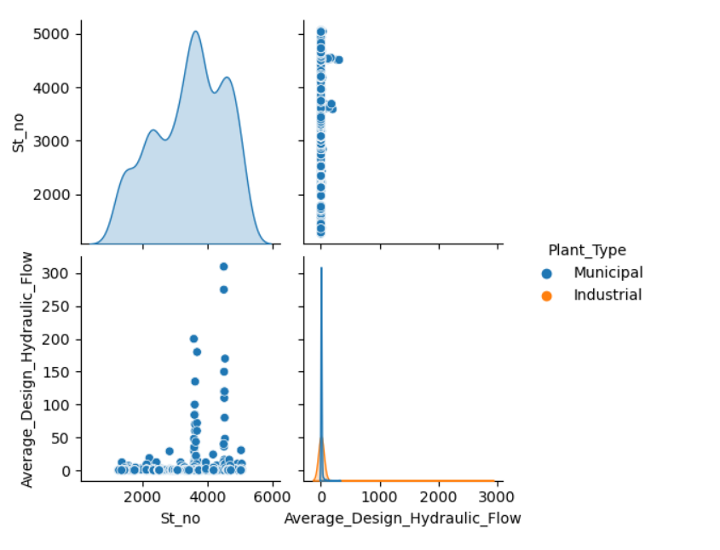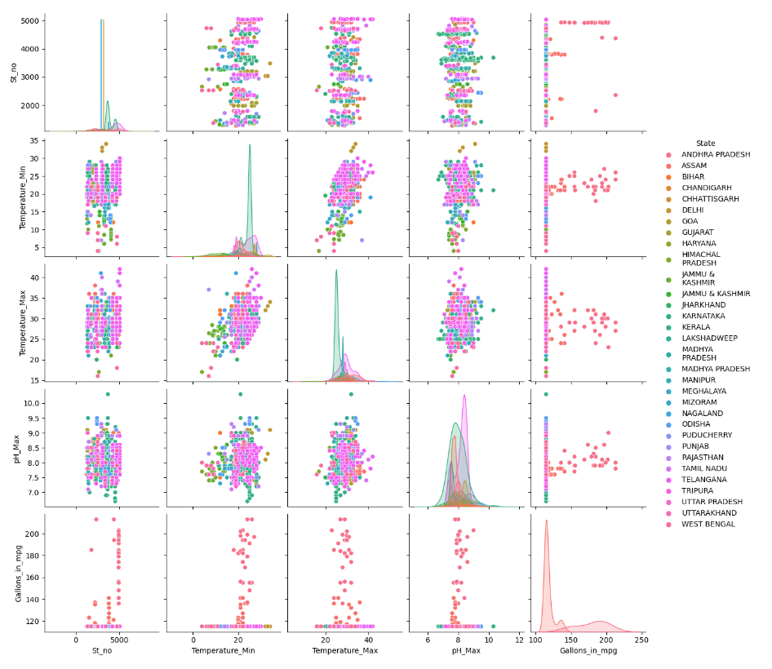

**CONCLUSION:**

We started off with our dataset where we decomposed the 1NF table to 2nd and verified it to be as BCNF and verified it using the lossless and we used php and advanced User Interface design to make our website to look the best, further more we used Jupyter notebook to make the analysis of the project look better.

**REFERENCE:**

1. **JotForm’s**
2. **Kaggle**
3. **Highcss**
4. **MySQL**
5. **Xampp**
6. **PhpMyAdmin**
7. **Jupyter notebook**